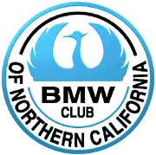
Bmw Norcal is proud to announce yet another Member Clinic, Advanced Riders Class hosted by Superbike-Coach Can Akkaya.
This class is customized for our club and its riding needs and will suit most riders.

When: April 7th 2019 at 9am to 4:30pm
Where: Little 99 Raceway 1658 S Airport Way Stockton CA 95206
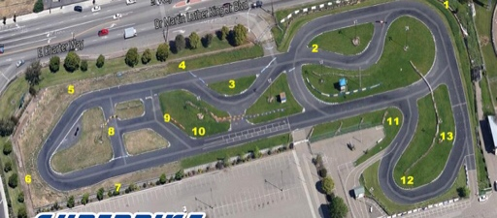
What to bring: Fresh tires and make sure brakes are within specs and a full tank of gas. Lunch can be ordered, otherwise pack what you want.
What to expect: A whole lot of fun and professional coaching on how to find and keep the riding line, waypoint viewing technique, mental aspects, trail braking, ‘uber’ counter steering (skills only Coach Can Akkaya teaches), brake to steer (a bad ass survival skill), ABS emergency braking. The day will be spent in class and on the track with drills and demos.
Cost: ForNorcal Members, cost is $139.00 + 2%c booking fee (includes access to the track and free sport photography, snacks and water)

Please visit www.superbike-coach.com/events/bmw-norcal-advanced-rider-class to sign up.

BmwNorcal will be applying for the Paul B. group scholarship from MOA. If we can get the scholarship funds we will distribute the funds back to the participants. So after registering on Superbike Coach’s website please visit BMWNorCal’s website and register there as well.

Please note, you should review your insurance policy carefully as your insurance may not cover incidents taking place on a racetrack.

Note! This class is limited to 30 riders so it is first come first serve.

Any questions please email Jorgen Larsen, safetydirector@Bmwnorcal.org

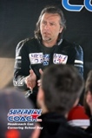
Can “Jon” Akkaya is a former professional motorcycle racer, writer, and founder of the Superbike-Coach Corp. Can is a passionate motorcycle riding coach and has taught thousands of students to be faster, more confident, and most importantly, safer riders. He is also official rider trainer of the United States Air Force.

